Invitation to stakeholders

Project: To Develop a Regional Marine Spatial Planning (MSP) Strategy for the Western Indian Ocean (WIO)

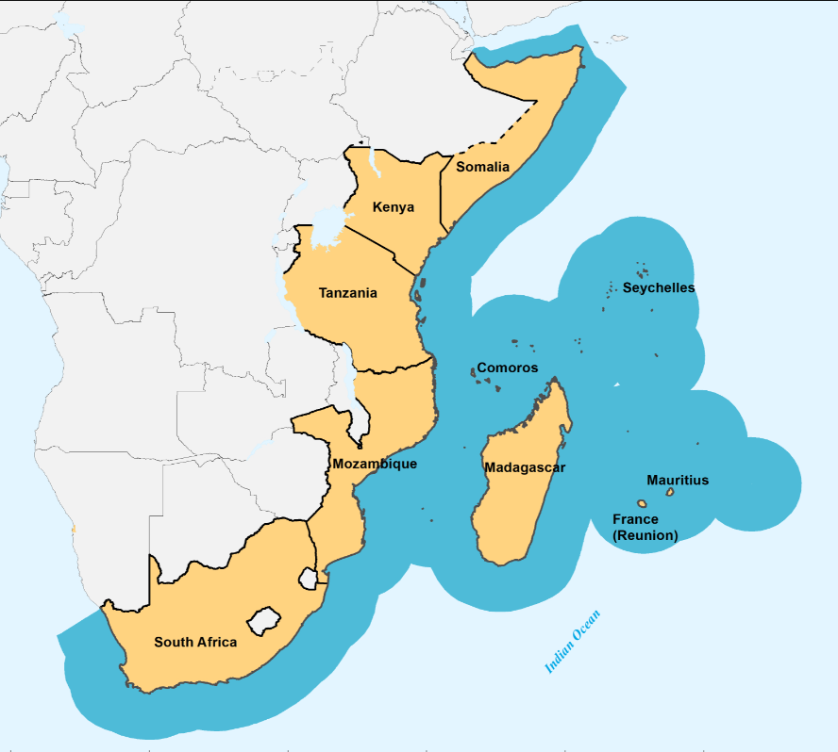
Following the request by the Contracting Parties to the Nairobi Convention for the Secretariat to develop a regional MSP Strategy for the western Indian Ocean region, the Institute for Coastal and Marine Research (CMR) at the Nelson Mandela University in Port Elizabeth, South Africa, has been contracted by the United Nations Environment Programme (Nairobi Convention Secretariat) to lead this process.
Figure 1. The ten countries included in the regional strategy
This strategy aims to address REGIONAL issues that cannot be addressed by national MSPs operating in isolation. The strategy will thus draw from, augment, support and where possible assist national MSP strategies, no matter their current stage of development.
The strategy will be a high-level document, developed in collaboration with the existing MSP Technical Working Group set up under the Nairobi Convention, with representatives from each of the ten Contracting Parties (Comoros Islands, France, Kenya, Madagascar, Mauritius, Mozambique, Seychelles, Somalia, South Africa and Tanzania), as well as the broader stakeholder community. You have been identified as a potential stakeholder and we welcome your input. In the interests of a bottom-up approach, we would have preferred in-country face-to-face meetings with all stakeholders, but given the global pandemic and travel restrictions, we are currently planning to conduct all our stakeholder interactions online.

How you can participate:
Should you wish to participate in this process, kindly register as a stakeholder by sending an email to the project coordinator, Dr Kaylee Smit (WIOMSP@gmail.com).
Once you are registered on our stakeholder database, we will make sure that you receive all invites/notifications related to the project.

Please use WIO MSP stakeholder as the subject for the email.

In your email, please answer the following three broad questions (open-ended, no word limits)
- What do you think should be included in an MSP strategy for the WIO region?
- How do you foresee the uptake and implementation of a regional MSP strategy in your country?
- In what way do you envision a regional MSP strategy will assist in supporting the objectives of your country?

Additionally, we have developed an online questionnaire that will be used to inform the development of the MSP strategy. We kindly ask you to complete this questionnaire at your earliest convenience.
Please click (control + left click) on the link below to access the online questionnaire. It should take approximately 15-30minutes to complete.
LINK: stakeholders

There is additional information on a dedicated web page on our website https://algoabaydata.wixsite.com/website/wio-msp. You will be able to view and download additional material of interest here, and you can send any documents of interest to Kaylee (via email), at any time.

Thank you so much for your time and we look forward to engaging meaningfully with you as we work towards a collaboratively developed regional MSP strategy for the WIO.

Sincerely

Dr Kaylee Smit (Project Coordinator & Point of Contact)
Prof Mandy Lombard & Dr Bernadette Snow (Principle Investigators)

